Procurement Analytics and Supplier Performance Optimization
DSC680-T301 Applied Data Science | Week 11 Final Project
By: Kayla Greavu
Date: 5/28/2026

Executive Summary
This final project analyzes procurement and supplier performance data to identify patterns in purchasing efficiency, delivery reliability, supplier risk, maverick spending, and cost savings. The dataset includes 5,200 procurement records across 15 suppliers and 57 variables. The analysis uses descriptive analytics, data visualization, correlation analysis, and a basic predictive model to evaluate procurement performance and recommend operational improvements.
KPI | Result
Records analyzed | 5,200
Unique suppliers | 15
Total net spend | $908.8M
Total savings | $104.3M
Average savings rate | 8.5%
On-time delivery rate | 64.1%
Average days late | 4.1 days
Maverick spend rate | 12.5%
Maverick net spend | $98.2M

Business Problem
Procurement departments manage purchase orders, supplier contracts, delivery schedules, invoices, and spending controls. When supplier performance is inconsistent, deliveries are late, or employees purchase outside approved procurement processes, organizations can experience higher costs and operational disruption. This project addresses the need for a data-driven way to evaluate supplier performance and identify procurement risks before they become larger supply-chain problems.

Background and History
Procurement analytics combines business intelligence and data science methods to improve supplier management, purchasing efficiency, and contract compliance. Modern procurement systems collect information on supplier risk, delivery timelines, contract type, invoice matching, payment status, pricing, discounts, and savings. Analyzing these records allows leaders to see performance patterns that may not appear in basic operational reports.

Data Explanation and Preparation
The analysis uses the Dataset_Procurement Excel workbook, primarily the Data worksheet. Important variables include Days Late, On Time Delivery, Supplier Risk, Preferred Supplier, Maverick Spend, Savings Amount, Savings Pct, Lead Time Days, Contract Type, Payment Status, and Supplier ESG Score. Date fields were converted into date formats, categorical fields were standardized, and binary flags were created for on-time delivery, maverick spend, preferred supplier status, and late delivery.

Methods
The project uses descriptive analytics to summarize spend, savings, delivery performance, supplier risk, and category trends. It also uses visualization to compare supplier groups, correlation analysis to evaluate delivery-delay drivers, a composite supplier scorecard for business ranking, and a logistic regression model to demonstrate how procurement records can support delivery-delay risk screening.

Analysis and Findings

1. Supplier Performance Scorecard
Supplier performance was evaluated using a composite score that weights on-time delivery, average savings percentage, ESG score, and lower supplier risk. Nordic Office Solutions ranked highest overall, followed by Blue Horizon Packaging and Pacific Rim Supplies. The scorecard is useful as a management tool because it balances reliability, financial value, sustainability, and risk rather than relying solely on cost.
Supplier | Records | On-time Rate | Avg Savings % | ESG | Score
Nordic Office Solutions | 380 | 64.5% | 8.5% | 89.1 | 77.8
Blue Horizon Packaging | 347 | 66.6% | 10.5% | 50.9 | 76.8
Pacific Rim Supplies | 346 | 62.7% | 8.4% | 77.2 | 74.6
Cornerstone Services | 337 | 66.5% | 8.5% | 67.8 | 74.4
EuroBuild Materials | 311 | 64.6% | 7.7% | 80.5 | 73.9
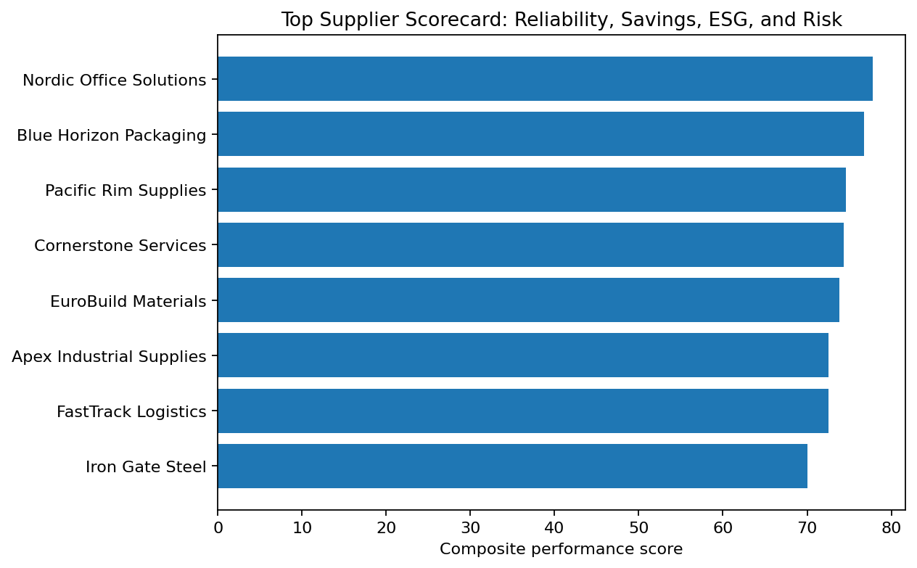
Figure 1. Top supplier scorecard based on reliability, savings, ESG, and risk.

2. Preferred Supplier Status
Preferred suppliers accounted for 1,703 records. However, their on-time delivery rate was 63.3%, compared with 64.5% for non-preferred suppliers. This result suggests that preferred status should not be treated as proof of better delivery performance. The preferred supplier list should be reviewed with current performance metrics.
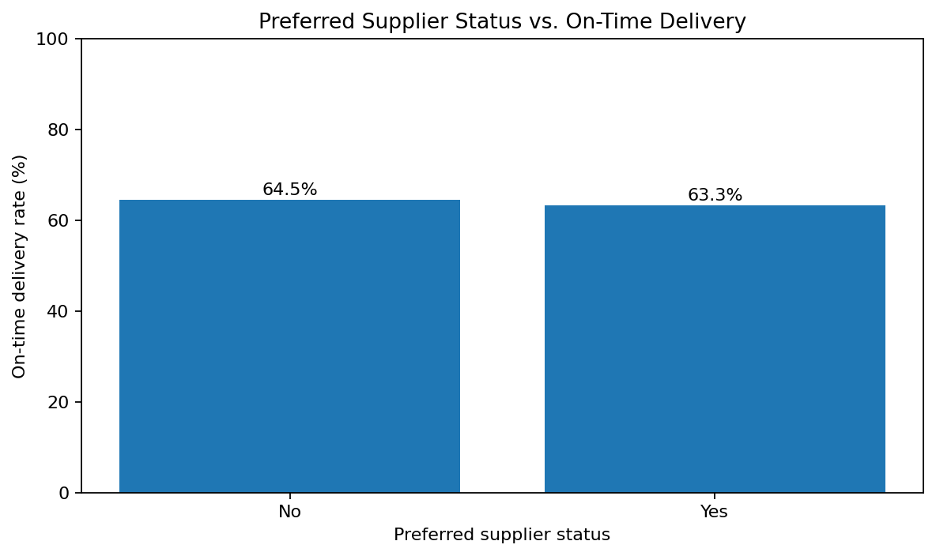
Figure 2. Preferred supplier status compared with the on-time delivery rate.

3. Supplier Risk and Delivery Delay
The relationship between supplier risk and delivery delays was small in this dataset. Low-, medium-, and high-risk suppliers all averaged about 4 days late. High-risk suppliers had a slightly lower on-time delivery rate and a slightly higher late rate, but the differences were not large enough to rely on risk category alone. Lead time showed a stronger relationship with Days Late than supplier risk did, suggesting that procurement teams should monitor long-lead-time orders closely.
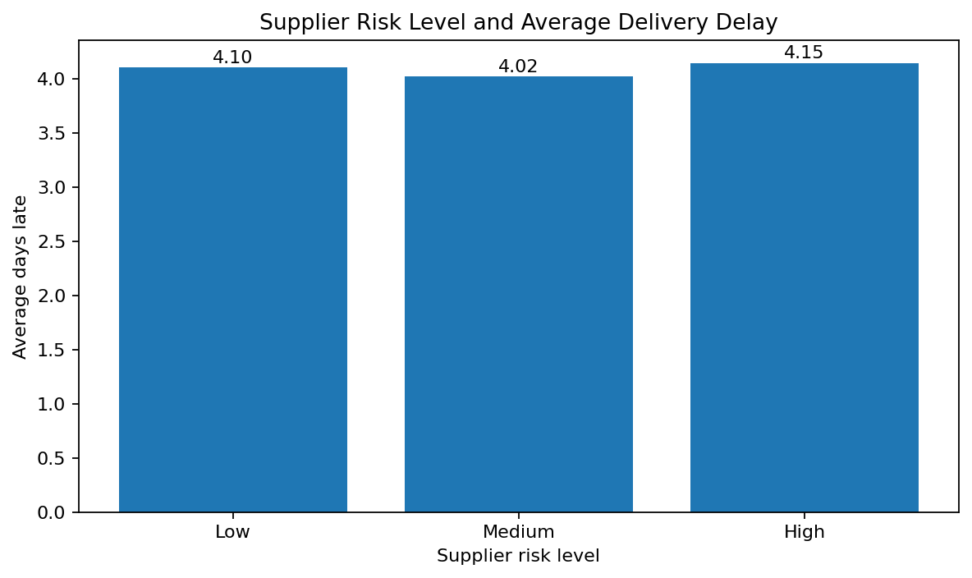
Figure 3. Supplier risk level and average delivery delay.

4. Maverick Spending
Maverick spend occurred in 12.5% of procurement records, totaling $98.2M in net spend. Maverick purchases averaged 4.43 days late, compared with 4.03 days for non-maverick purchases. Even when savings percentages are similar, maverick spending remains a control concern because it undermines contract compliance and makes purchasing harder to manage.
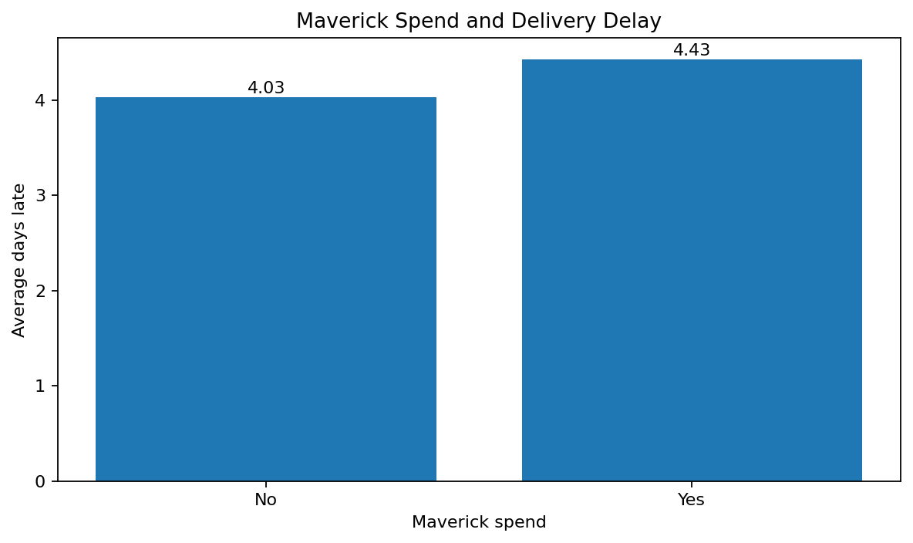
Figure 4. Maverick spends and has an average delivery delay.

5. Procurement Category Spend
The largest spending category was IT Software at $299.6M, followed by Professional Services at $163.9M. These categories should receive priority in contract review and supplier negotiations because small efficiency improvements in high-spend areas can produce large savings.
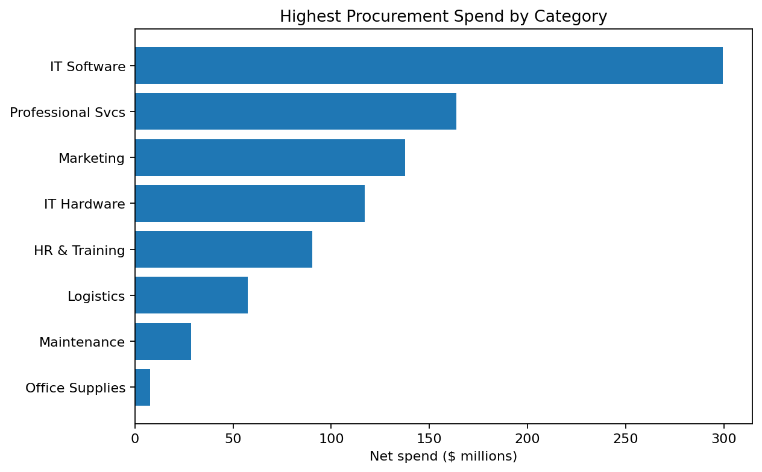
Figure 5. Highest procurement spend by category.

Predictive Modeling Summary
A logistic regression model was used to estimate the likelihood that a record would be late. The model produced an ROC AUC of 0.75, indicating limited but useful separation between late and not-late records. A linear regression model for Days Late produced an R-squared of 0.26 and a mean absolute error of 7.03 days. The strongest numeric predictor was Lead Time Days, while other fields had weaker direct relationships. This model should be viewed as a first-pass risk flag, not an automated decision system.

Conclusion
The analysis shows that procurement analytics can help organizations evaluate supplier performance, identify control issues, and prioritize improvement opportunities. The clearest findings are that maverick spending accounts for a meaningful share of spend, preferred suppliers do not clearly outperform non-preferred suppliers in this dataset, and lead time is a useful indicator of delivery-delay risk. Supplier scorecards can improve decision-making by combining reliability, savings, ESG performance, and risk into a single review process.

Recommendations
- Build a formal supplier scorecard using on-time delivery, savings rate, ESG score, and supplier risk.
- Review the preferred supplier list quarterly and require measurable performance standards for preferred status.
- Reduce maverick spending by strengthening approval workflows, improving contract visibility, and implementing purchase-order controls.
- Monitor long-lead-time orders as early warning indicators of potential delays.
- Focus contract negotiation and process improvement efforts on high-spend categories such as IT, Software, and Professional Services.

Implementation Plan
Phase | Action | Outcome
1. Data governance | Standardize supplier names, status values, and date fields. | Cleaner procurement reporting
2. Supplier scorecard | Create a dashboard with supplier KPIs and composite rankings. | More consistent supplier evaluation
3. Maverick spends controls | Add approval checks for non-contract purchasing and exceptions. | Improved contract compliance
4. Delay-risk monitoring | Flag long lead-time and high-risk orders for procurement review. | Earlier intervention on delayed orders
5. Review cycle | Review KPIs quarterly and update supplier strategy. | Continuous improvement

Assumptions, Limitations, and Challenges
- Assumptions: Supplier risk scores, ESG ratings, delivery dates, and savings calculations are assumed to be accurate and consistently recorded.
- Limitations: The analysis identifies patterns but does not prove causation. Some procurement outcomes may be affected by external factors not captured in the dataset, such as weather, supplier capacity, commodity shortages, or transportation disruptions.
- Challenges: The dataset contains many categorical variables, so the most important challenge was selecting meaningful procurement KPIs and interpreting them carefully without overclaiming causality.

Future Uses and Additional Applications
Future versions of this project could use more advanced predictive modeling to forecast delivery delays, detect potential procurement fraud, identify suppliers most likely to miss delivery targets, or optimize supplier selection by balancing price, reliability, risk, and ESG goals. Additional external data, such as shipping conditions or supplier capacity, could improve predictive accuracy.

Appendix A: Q&A
Q: Which suppliers demonstrated the best overall performance?
A: Nordic Office Solutions, Blue Horizon Packaging, and Pacific Rim Supplies ranked highest on the composite scorecard: the ranking balances on-time delivery, savings, ESG score, and lower risk.
Q: What was the biggest operational risk found in the data?
A: Maverick spending is a major control risk because it appeared in 12.5% of procurement records and represented about $98.2 million in net spend.
Q: Are preferred suppliers always better?
A: No. In this dataset, preferred suppliers did not clearly outperform non-preferred suppliers on on-time delivery or average days late, so preferred status should be reviewed using current performance data.
Q: What factor was most related to late deliveries?
A: Lead Time Days had the strongest relationship with Days Late among the numeric variables analyzed. Longer lead-time orders should receive earlier monitoring.
Q: Do high-risk suppliers have much worse delivery performance?
A: High-risk suppliers were slightly worse on some delivery measures, but the difference was small. Supplier risk alone should not be the only basis for decisions.
Q: How much savings did procurement generate?
A: The dataset shows total savings of approximately $104.3M, with an average savings rate of 8.5%.
Q: Which category should be prioritized first?
A: IT Software should be prioritized because it had the largest net spend, approximately $299.6M.
Q: Can this analysis be used to automate supplier selection?
A: Not by itself. The model should support, not replace, human decision-making, because procurement decisions can affect suppliers and operations in ways the dataset may not fully capture.
Q: What ethical concerns apply?
A: Supplier evaluations can introduce bias if data is incomplete or interpreted without context. Smaller suppliers could be unfairly penalized if automated scoring is used without review.
Q: What should be done next?
A: The organization should build a recurring procurement dashboard, review preferred supplier criteria, monitor maverick spend, and improve delay-risk screening for long lead-time orders.

References
Gartner. (2024). Procurement analytics and supplier management insights. https://www.gartner.com/en/supply-chain
McKinney, W. (2022). Python for data analysis (3rd ed.). O’Reilly Media.
Pandas Development Team. (2025). Pandas documentation. https://pandas.pydata.org/
Scikit-learn Developers. (2025). Scikit-learn documentation. https://scikit-learn.org/

